**Selecting the best location for Indian Cuisine in Toronto**

Hiralkumar Modha

December 15, 2020

**1. Introduction**

**1.1 Background**

Toronto’s demographics show that it is a large and ethnically diverse metropolis. It is the largest city in Canada with a long history of international immigration. Greater Toronto Area was home to nearly 6.4 million people in 2016, accounting for about half the population Ontario. Over the last decade the city has been growing faster than the region. The Greater Toronto Area continues to be by far the leading metropolitan gateway for legal immigrants in Canada.

Toronto is an international centre of business, finance, arts, and culture, and is recognized as one of the most [multicultural](https://en.wikipedia.org/wiki/Multiculturalism) and [cosmopolitan](https://en.wikipedia.org/wiki/Cosmopolitanism) cities in the world. The diverse population of Toronto reflects its current and historical role as an important destination for [immigrants to Canada](https://en.wikipedia.org/wiki/Immigration_to_Canada). More than 50 percent of residents belong to a [visible minority](https://en.wikipedia.org/wiki/Visible_minority) population group, and over 200 distinct [ethnic origins](https://en.wikipedia.org/wiki/Ethnic_group) are represented among its inhabitants. While the majority of Torontonians speak [English](https://en.wikipedia.org/wiki/English_language) as their primary language, over 160 languages are spoken in the city.

With it’s diverse culture, comes diverse food items. There are many restaurants in Toronto, each belonging to different categories like Chinese, Indian, French and Italian etc.

So as part of this project, we will list and visualise all major parts of Toronto that has great Indian restaurants.

**1.2 Business Problem**

Toronto has a diverse population and thus it has diverse food culture also. So, to find a specific type of food or cuisine, let’s say Indian, it will be very difficult. So, this project will help answer following questions.

1. What is best location in Toronto for Indian Cuisine?
2. Which areas have potential for opening Indian Restaurant?
3. Which is the best place to stay if I prefer Indian Cuisine?

**1.3 Stakeholders**

Stakeholders for this project can be common people who are travelling to Toronto and have interest in having Indian cuisine. Also, the investors who want to open an Indian Restaurant in Toronto, and looking for better place for it.

**2. Data**

For the project we need following data:

* Toronto data that contains list Boroughs, Neighbourhoods along with their latitude and longitude.

Source: Wikipedia page containing List of postal codes, Boroughs and neighbourhoods. By scraping the Wikipedia page <https://en.wikipedia.org/wiki/List_of_postal_codes_of_Canada:_M>, Latitude and longitudes can be obtained from [http://cocl.us/Geospatial_data](https://cocl.us/Geospatial_data) and both can be merged to one data frame.

* Indian restaurants in each neighbourhood of Toronto.

Source: Fousquare API

Description: By using this API we will get all the venues in each neighbourhood. We can filter these venues to get only Indian restaurants. We can find the ratings of selected Indian Restaurants.

**3 Methodology**

* Collect Toronto borough data from https://en.wikipedia.org/wiki/List_of_postal_codes_of_Canada:_M and Latitude and Longitude of Neighborhoods from [http://cocl.us/Geospatial_data](https://cocl.us/Geospatial_data)
* Using FourSquare API we will find venues for each neighbourhood.
* Filter out all venues that are Indian Restaurants.
* Find rating, tips and likes count for each Indian Restaurants using FourSquare API.
* Using rating for each restaurant, we will sort that data.
* Visualize the Ranking of neighbourhoods using folium library (python).

**3.1 We will import the required libraries for python**

* Pandas and numpy for handling data.
* Request module for using FourSquare API.
* Geopy to get co-ordinates of Toronto.
* Folium to visualize the results on a map.

**3.2 Collecting and cleaning Toronto Data**

Initially when we scrap the Wikipedia page of Toronto postal code and convert it to Pandas dataframe, we get some postal codes without boroughs. We need to drop those postal codes. Also we need to drop duplicate postal codes. Then, we are left with some boroughs which does not have Neighborhoods, so we need to replace the Neighborhood name with Borough name.

Then from another data frame we get Latitude and Longitudes of Toronto Neighborhoods. Then we merge both the data frames based on Postal Code, and drop the duplicate column of Postal code.

**3.3 Define the function for Foursquare API for searching Venues**

Firstly we have to define a function to get the geocodes i.e latitude and longitude of a location using geopy. Then, we will define two functions for Foursquare API. First, we will define a function to intract with FourSquare API and get top 100 venues within a radius of 1000 metres for a given latitude and longitude. This function will return us the venue id, venue name and category. Then, we will define a function to get venue details similar to like count, rating, tip counts for a given venue id. This will be used for ranking the venues.

**3.4 Collect the list of Indian Restaurants in each Neighborhood of Toronto**

Using the data frame of Toronto neighborhoods, Latitude and Longitude along with Foursquare API function create a list of Indian Restaurants in each neighbourhood and convert it in to a data frame having Borough, Neighborhood, ID and Name of Restaurant.

**3.5 Analyze the data collected**

Analyze the list of Indian Restaurants based on number in each Borough and each neighborhood. By doing this we can get idea about density of Indian Restaurants in different neighborhoods and Boroughs.

**3.6 Get Ranking of each Indian Restaurant**

Then we will get the ranking of each Indian restaurant based on Foursquare API call and getting details on Likes, Rating and Tips, and converting it to a data frame which we will be using in further analysis. By doing this we can get idea about each restaurant and ratings given by local people for each restaurant. As, this will be premium call of Foursquare API, save the data frame created in to a CSV file, so that it can be used when needed later.

**3.7 Find Indian Restaurant with Maximum Rating**

Then we will find the location of Indian restaurant with maximum likes, rating and tips along with its Borough and Neighborhood. Which can help the person who wants to have best Indian Cuisine in Toronto.

**3.8 Visualize Neighborhoods and Boroughs with descending Average Rating**

Sort neighborhoods and boroughs with Average rating to find out which neighborhoods are having best Indian Restaurants.

**3.9 Select neighborhoods with Rating above a limit and plot on map**

Then, we will select neighbourhoods having average rating above 8.0 and plot those neighbourhoods on map using Folium.

**4 Results & Discussion**

After collecting and cleaning Toronto Boroughs, Neighborhoods, Latitude and Longitude data the resulting data frame was having 103 neighborhoods in total. It looked as follows.

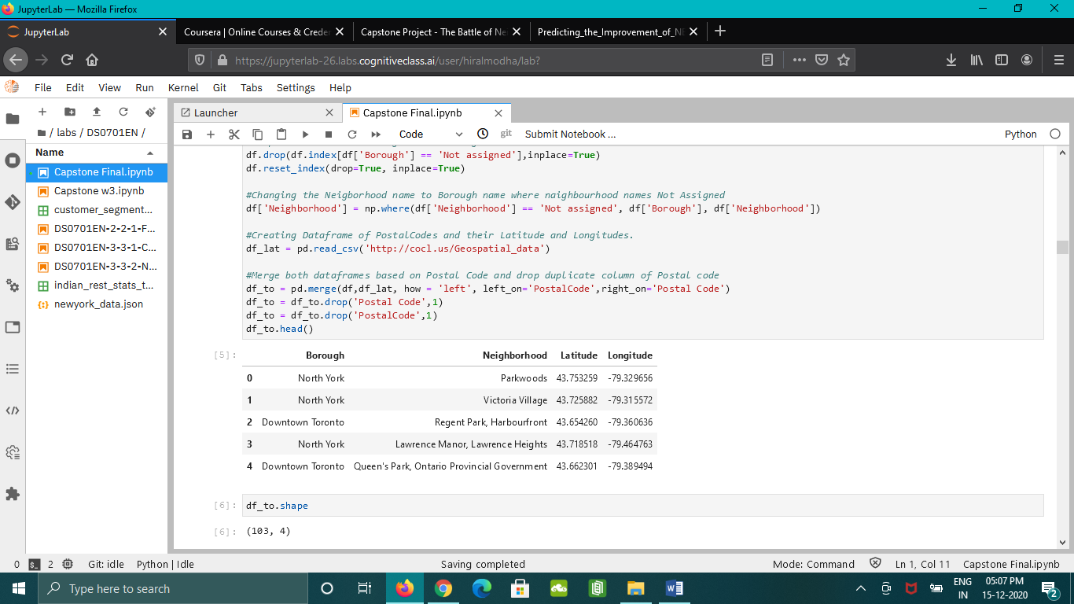

There are in total 10 boroughs in Toronto. Following graph shows the number of neighborhoods in each borough. North York has maximum neighborhoods and count to 24, while Mississauga has only 1 neighborhood.

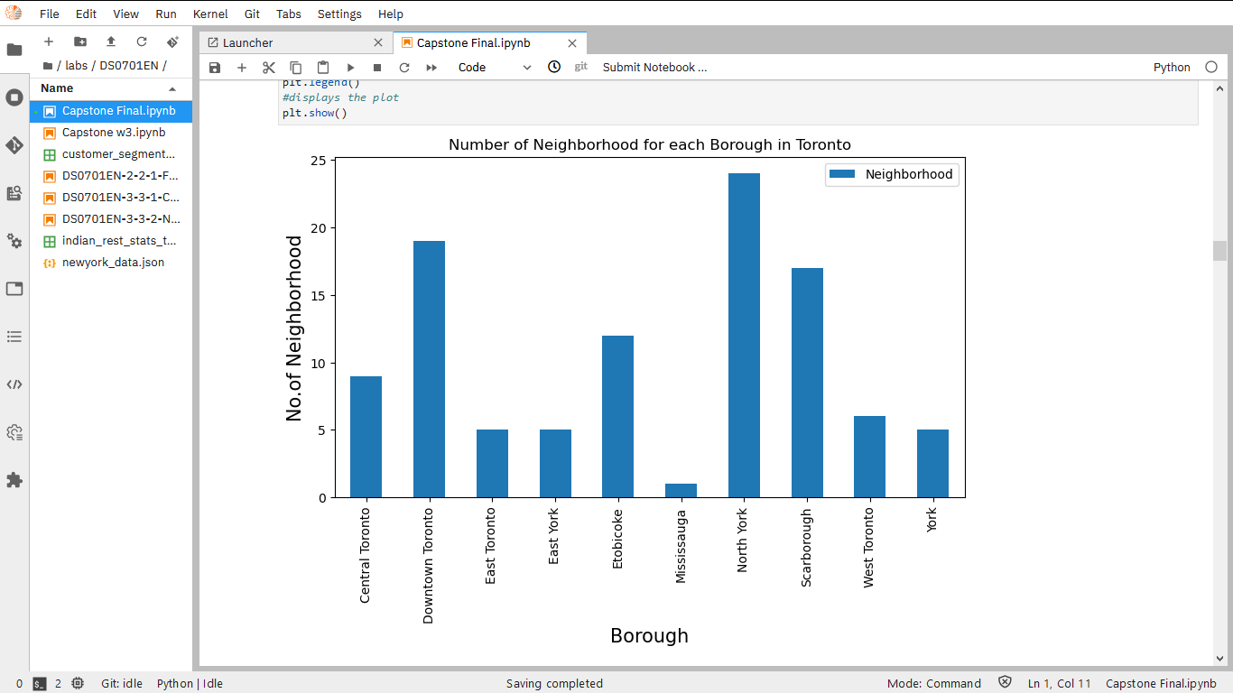

Considering radius of 1000 m we collected the details of Indian restaurants in each neighborhood. In total we found 50 Indian restaurant across Toronto neighborhoods. The maximum number of Indian Restaurants were located in East Toronto, which counts to 11 restaurants.

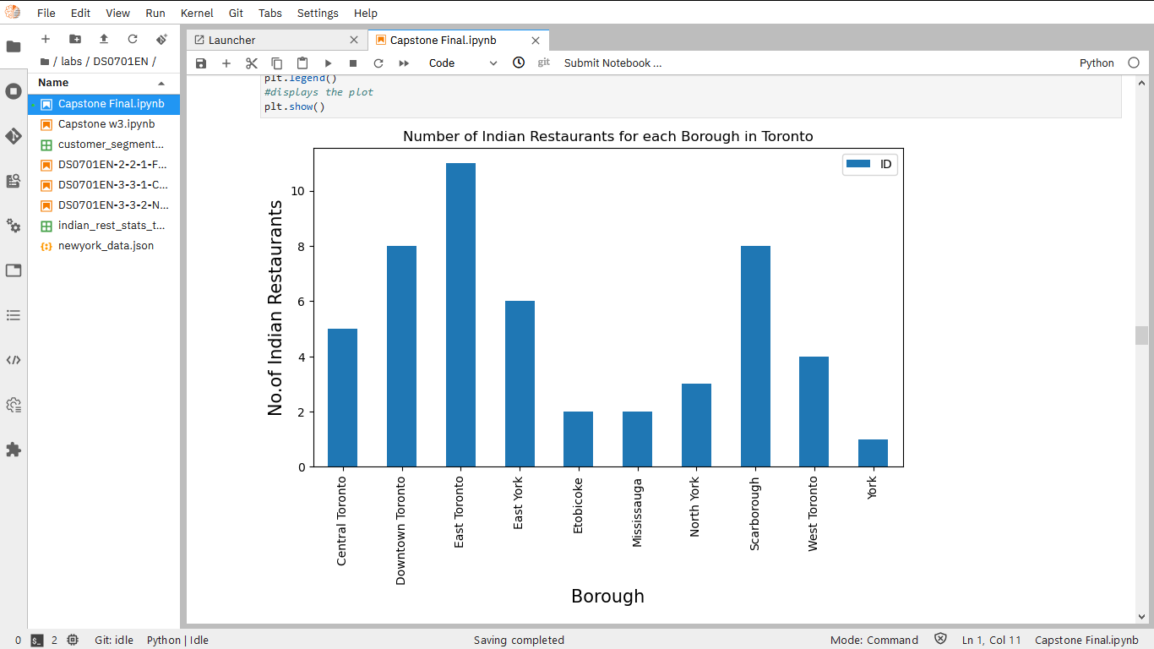

When we think of finding top 5 neighborhoods in Toronto with Highest number of Indian restaurants, it was India Bazaar, The Beaches West which was having maximum numbers of Indian Restaurants, a total of 8. This neighbourhood was also part of East Toronto which has maximum number of Indian Restaurants.

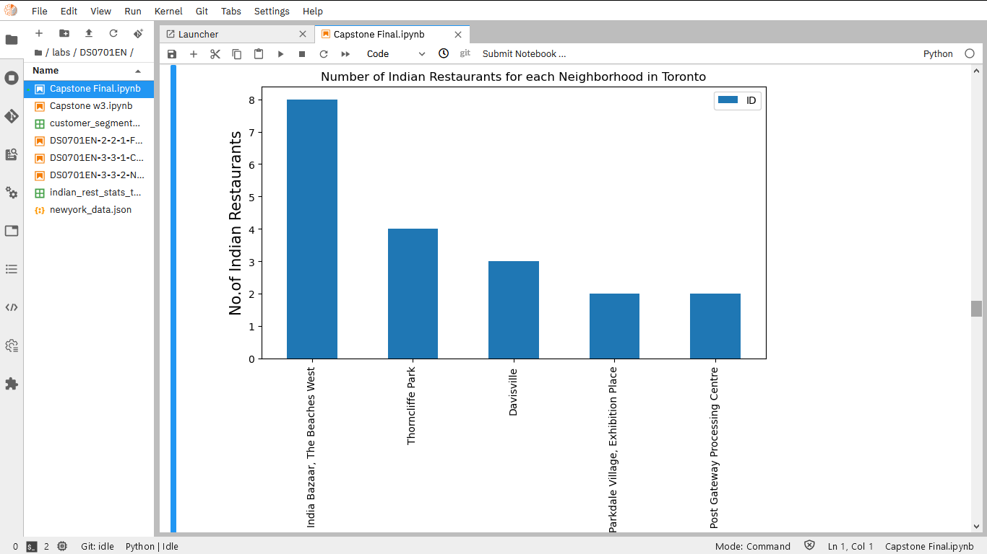

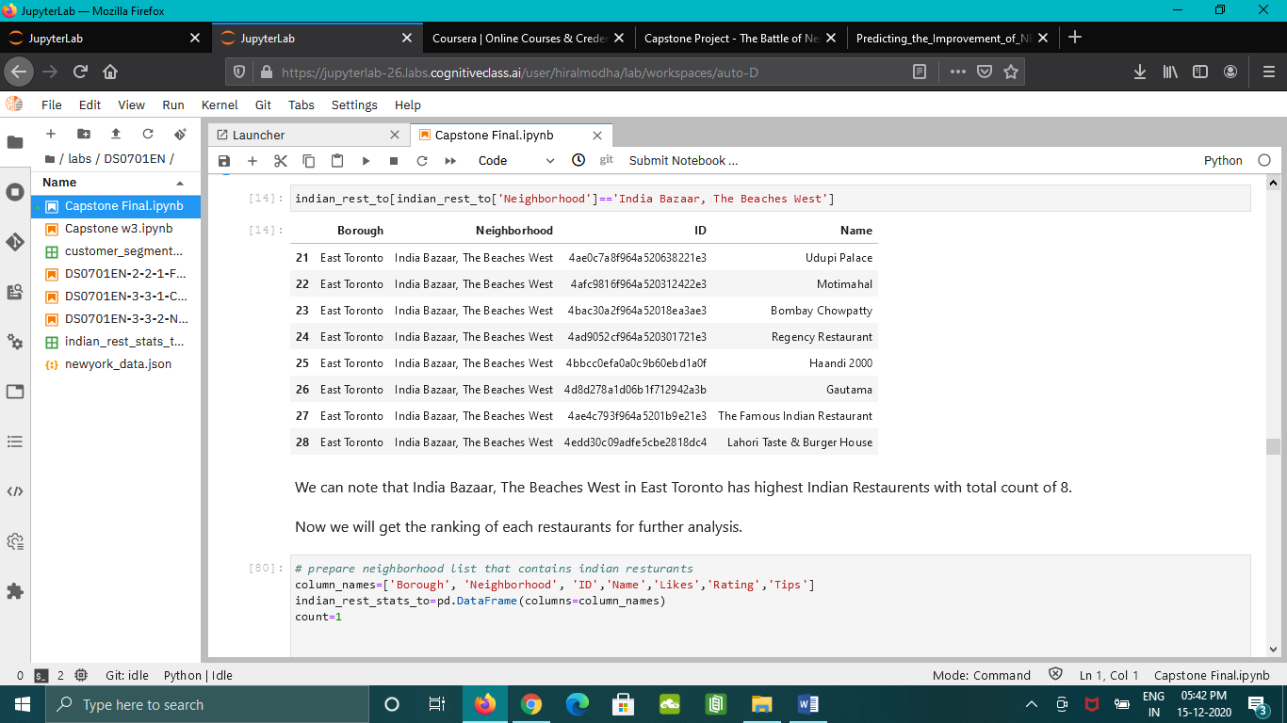

Then we collected the likes, rating and tips of each Indian restaurants to determine which ones are best Indian restaurants out of our list. Some of them were either new or does not have data for likes, rating and tips on Foursquare database then we put zero to avoid NaN values. Then we converted the results in to pandas data frame.

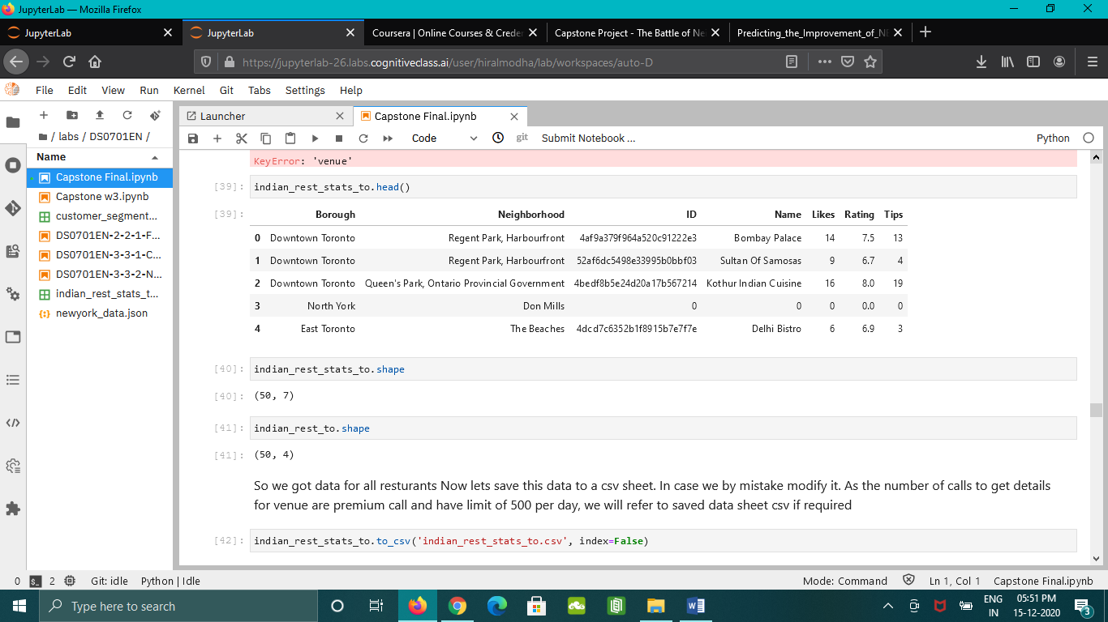

Then we looked for Restaurants with Maximum likes, rating and tips. Banjara Indian Cuisine in Christie in Downtown Toronto was found to have maximum likes, rating and tips of 142, 8.6 and 75 respectively.

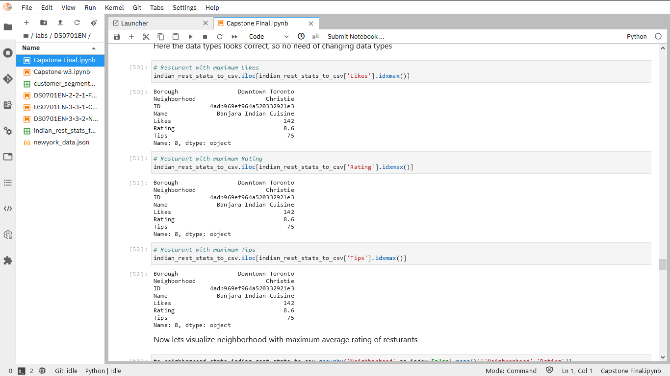

Then we found neighborhoods with Average Ratings of Indian Restaurants and sort them in descending order to get neighbourhood having highest average rating for Indian restaurants. St. James Town, Cabbagetown and High Park, The Junction South were having highest average rating of 8.3.

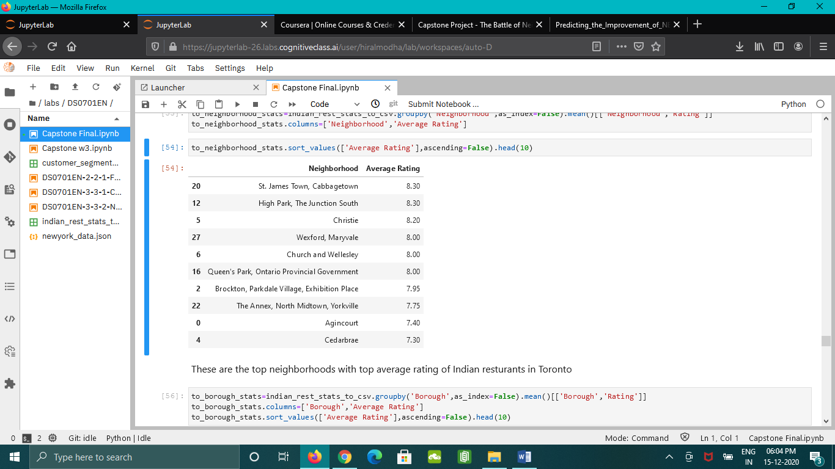

Similarly we sorted each borough in Toronto based on Average Rating of Indian Restaurants. West Toronto was having highest average rating of 7.80. Then we plotted the same on a graph and visualized that Downtown Toronto was also not much far from West Toronto. While North York was having minimum average rating of 4.47.

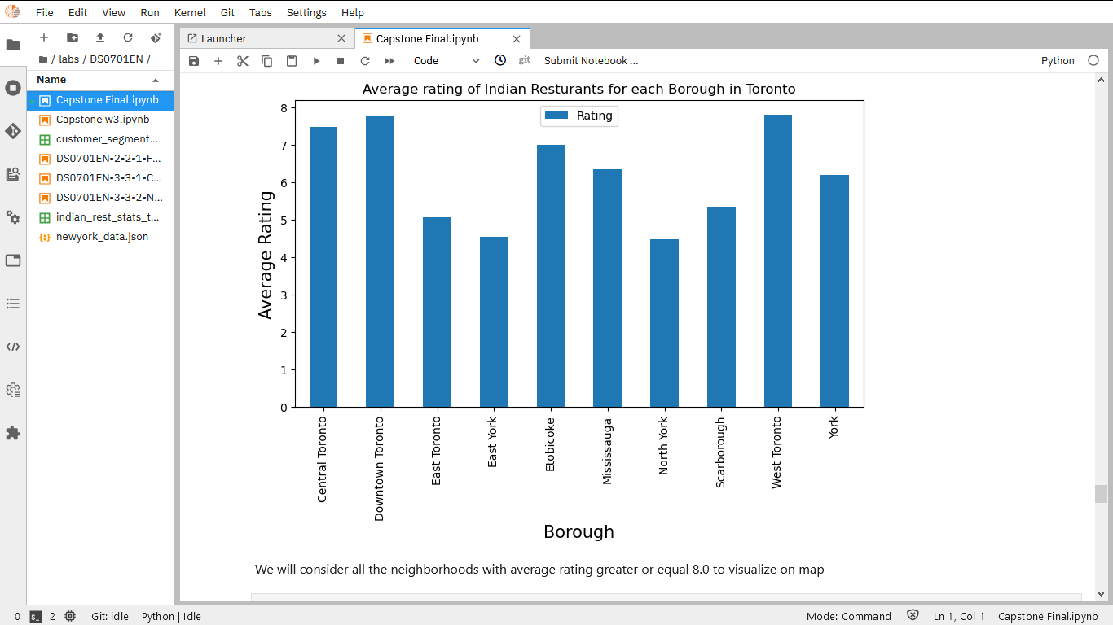

Then we selected neighborhoods having average Indian Restaurant rating of 8.0 and above and plotted it using folium to get idea about neighborhoods where Indian restaurant competition is more.

**5 Conclusion**

1. Christie and St. James Town, Cabbagetown in Downtown Toronto and High Park, The Junction South in West Toronto are some of the good neighborhoods for having Indian Cuisine.
2. West Toronto and Downtown Toronto has potential Indian Restaurant Market.
3. North York ranks last in average rating of Indian Restaurants. It can be an emerging market for opening an Indian Restaurant as it will not be having much competition.
4. Downtown Toronto is the best place to stay if you prefer Indian Cuisine.

**6 Limitations of Project**

* The ranking is purely on basis of rating of restaurants.
* The accuracy of data depends purely on the data provided by FourSquare database.